**Lab Tutorial 5: Inverse Dynamics (ID)**

OpenSim can solve the equations of motion for a multi-body system and calculate an inverse dynamic analysis. This is where you estimate the joint torques (or moments) that are responsible for causing the measured motion and forces. Motion files from inverse kinematics and forces (typically from force plates) are used as input.

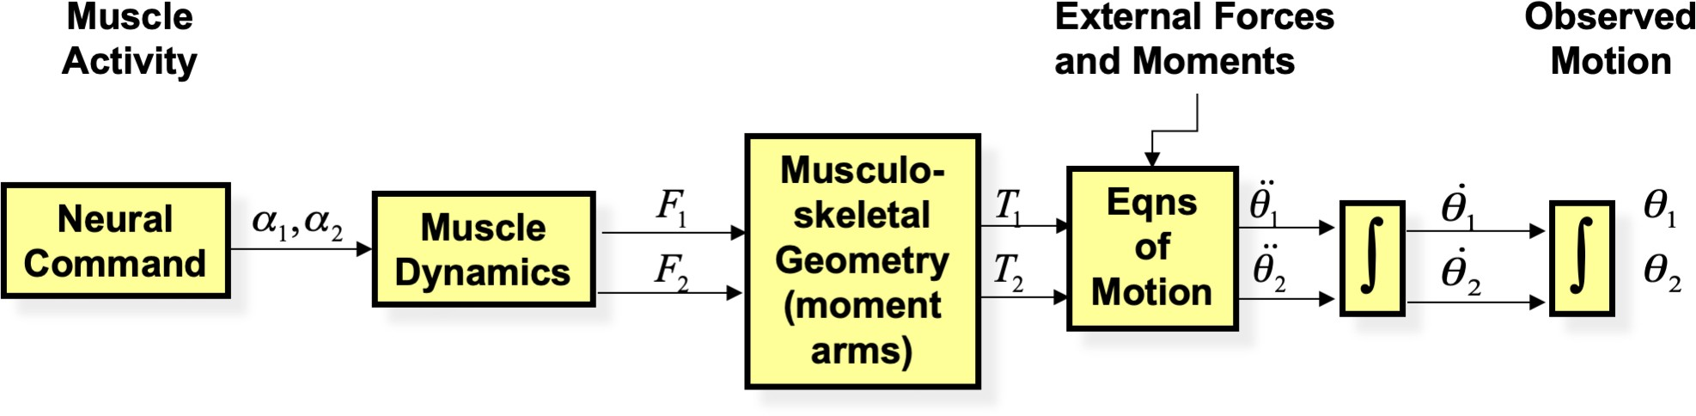

*Figure 1. Inverse dynamics analysis takes observed motion and measured external forces to solve equations of motion. In human simulations we typically calculate joint torques and forces around our joints. In this manner we gain insight into the function of muscles that produce these torques.*

# Task 1. Prepare and visualise motion data and external forces.

Before you run inverse dynamics, you should make sure you have already run an IK solution on your data and you have checked the solution to make sure it is a close match to your experimental marker data. It is also necessary to prepare the external forces, which involves making sure they are in the correct coordinate system (same as the motion data) and they are properly filtered. OpenSim will provide a filtering option for the motion data, but NOT for the force data, so you have to do this prior to running an ID analysis in OpenSim.

If you have already run an IK solution, the motion data will be highlighted in the Navigator. If not, load your scaled model into OpenSim and then load the walking.mot file that you have generated from the previous tutorial using *jw_ngait_og1.c3d*. Preview the walking data to make sure it looks ok.

[Right click on the motion in the Navigator window and select Associate Motion Data… and select the .mot file that contains the ground reaction force data]

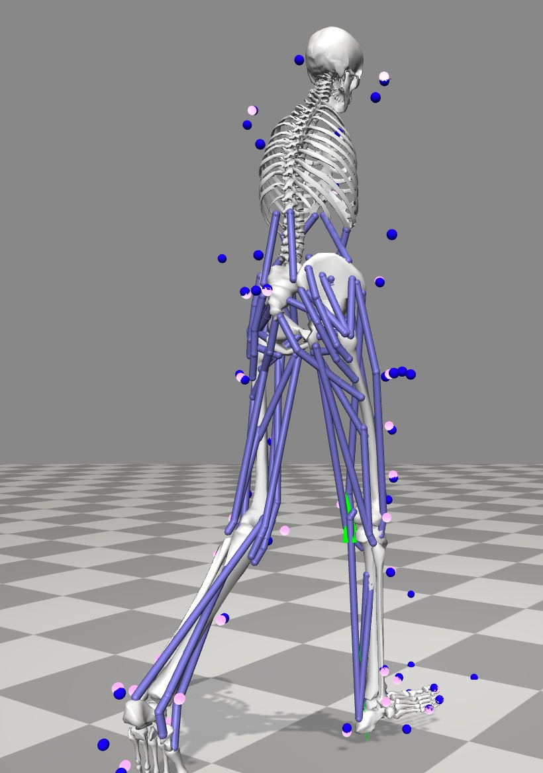Now you should be able to visualize the reaction forces at the ground as the model walks along. It is important to identify which body these forces make contact with, because when we set up ID, we have to tell OpenSim which body to apply these forces. You can also Associate the .trc file if you want to also compare the experimental markers (as shown on the right).

If your forces are not appearing close to the feet, then it is likely that the coordinate systems of either the markers or the GRFs have not been rotated.

# Task 2. Setting up Inverse Dynamics

[In the main menu, select Tools > Inverse Dynamics…]

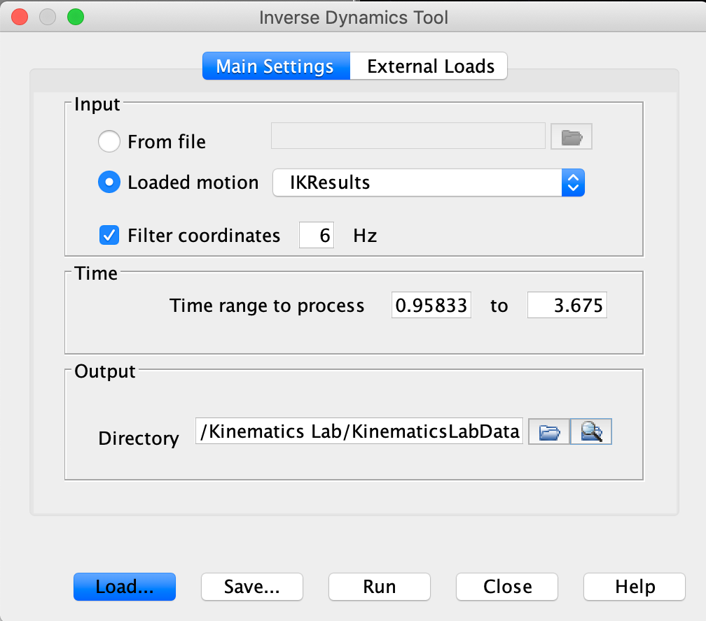This brings up the main menu settings for Inverse Dynamics. Here you can select which motion to choose as an Input. You can select the .mot file directly, or select a motion which is already loaded (as below). Here you should also choose to filter the coordinate data using an appropriate cut off frequency. Remember, this cut off frequency should match the cut off frequency that you have used to filter the reaction forces, to ensure **dynamic consistency**! By default the working directory that you are in is selected as the Output directory.

Now we have to select the .mot file that contains our force data and tell OpenSim which body to apply these forces.

[select the External Loads tab at the top]

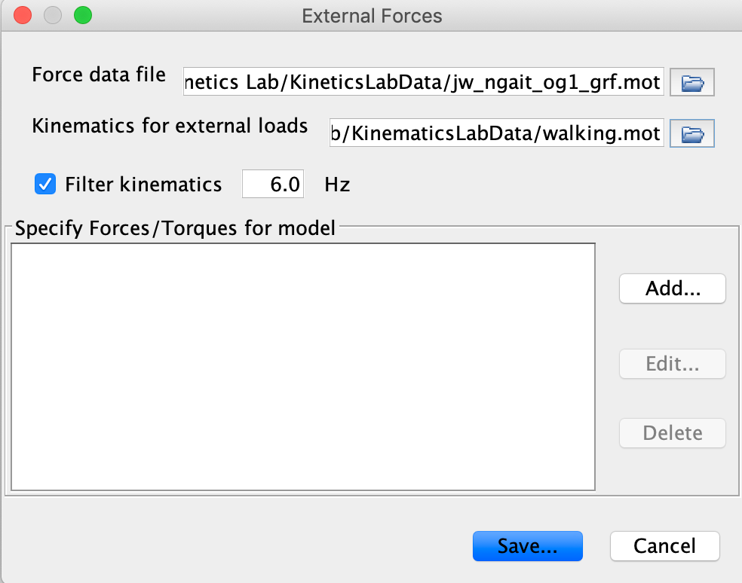This brings up the External Forces menu. The first thing to do is select the *_grf.mot file, which contains the forces from the force plate. You also need to specify (again, don’t ask me why) the motion file which contains the kinematics and select the appropriate cut off frequency for filtering.

[Now click Add… and we will describe how the forces are applied to the body]

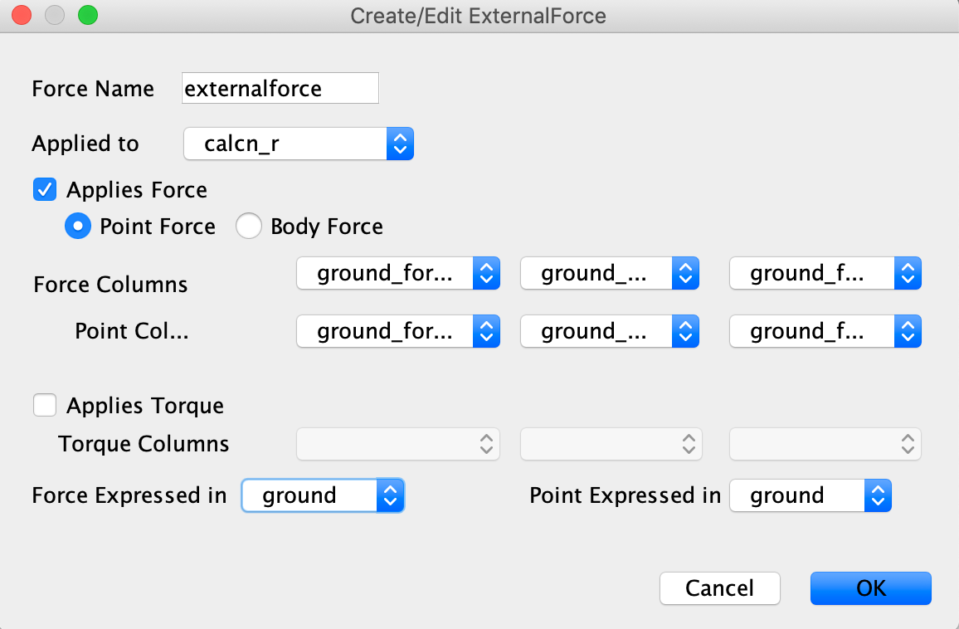

Provide a name for the forces. By default, OpenSim calls this *externalforce*. If you have more than one force, it might make sense to give this a sensible label so you know which force is applied to which body. In the Applied to drop down menu, select the right calcaneus body (calcn_r), as this is the body that is in contact with the force.

The drop down menus for the force and point columns provide selections from the .mot file to ensure you are applying the correct *forces* (_v) and centre of pressure (or *points*, _p) to the body. You can also specify if these forces and points are expressed in the ground or body coordinate frame. In our examples we have all of our forces and points expressed in the ground coordinate frame. You can also select to apply Torque, but leave this blank for now.

Your selections should match those in the figure above.

[Click OK to bring you back to the External Forces menu] [Now Save these settings as an .xml file by selecting Save…]

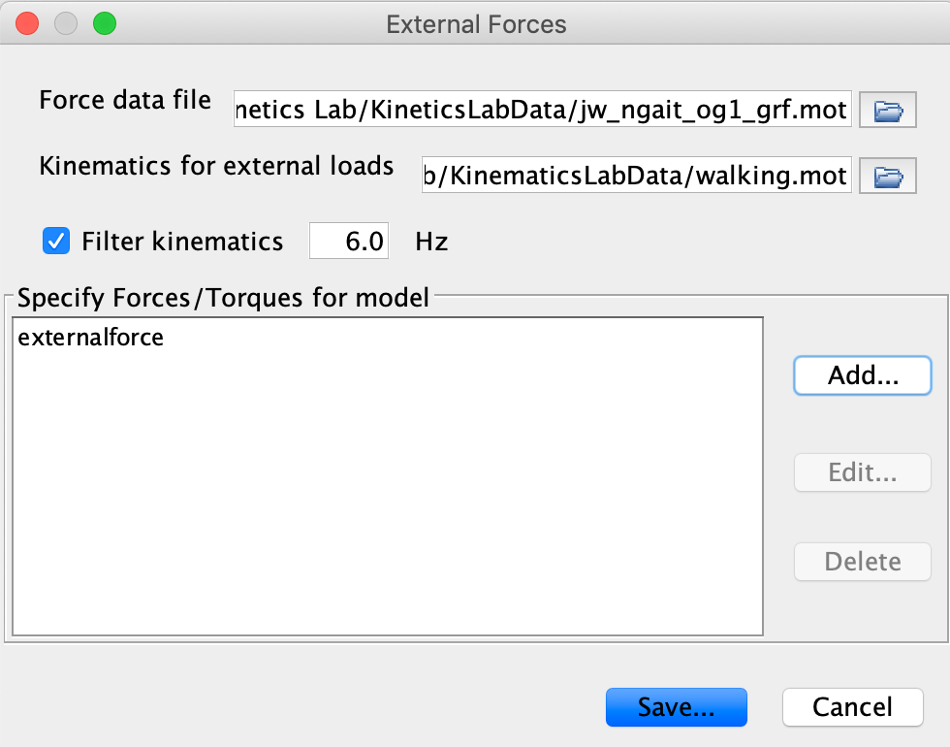

# Task 3. Running Inverse Dynamics

After saving the settings, you are now taken back to the main ID window. You will see the specification file that you have just saved.

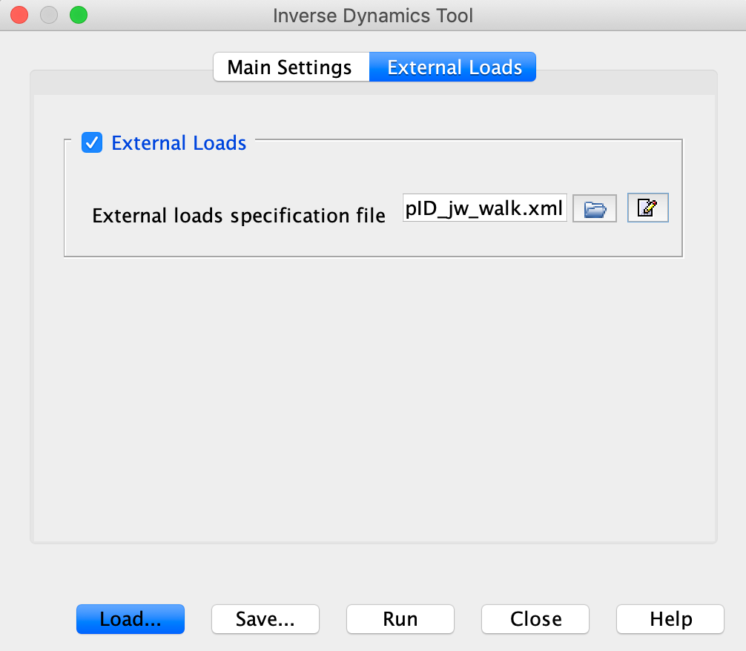Select Run and you will see the model move through each frame, calculating the inverse dynamics solution. OpenSim will generate a new storage file, called inverse_dynamics.sto, which will be located in the directory that you specified as the Output directory. You can now load this file and plot the inverse dynamics results (in OpenSim or Python).